Lesson 1:

Video 17:

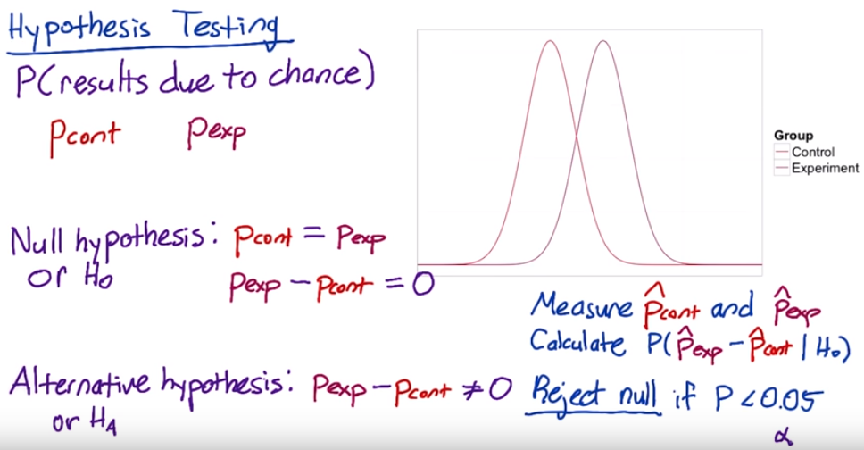

**Two-tailed vs. one-tailed tests**

The null hypothesis and alternative hypothesis proposed here correspond to a two-tailed test, which allows you to distinguish between three cases:

1. A statistically **significance** positive result
2. A statistically **significance** negative result
3. No statistically **significance** difference.

Sometimes when people run A/B tests, they will use a one-tailed test, which only allows you to distinguish between two cases:

1. A statistically **significance** positive result
2. No statistically **significance** result

Which one you should use depends on what action you will take based on the results. If you're going to launch the experiment for a statistically **significance** positive change, and otherwise not, then you don't need to distinguish between a negative result and no result, so a one-tailed test is good enough. If you want to learn the direction of the difference, then a two-tailed test is necessary.

Video 19

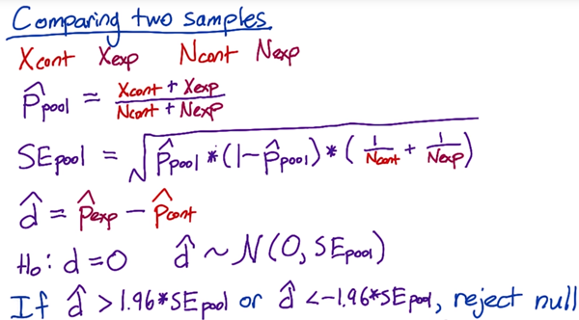

We have control how many pages views go into our control group and experiment group. Then we decide how many page views we need in order to get a statistically **significance** result.

Video 22 no fully understand

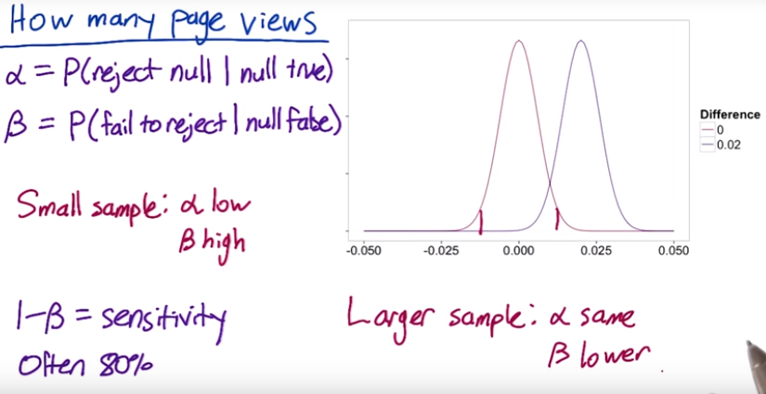

**Video 23 calculate number of Pages Views Needed**

Use a table <https://www.research-advisors.com/tools/SampleSize.htm>

Use online calculator <http://www.evanmiller.org/ab-testing/sample-size.html>

How many page views will we need for each group?

We collect 1000 unique pages view, of which 100 resulted in a click, practical **significance** is 2% (2% change in click through rate is **significance**)

α=0.05 β = 0.2 (pretty standard) ,

Sensitivity is 1-β = 0.8, (people often choose 80%)

Video 24

Standard error depends on click through probability SE = , so if increase the conversion rate(click Through Probability) will need to increase sample size to keep SE constant.

Video 25 Calculating Results

= 10072 = 9886 = 0.02 (practical significance level)

= 974 = 1242 confident level = 95%

pool = = 0.111

SE pool = = 0.00445

Estimated difference: = 0.0289 margin error: m = SE pool * 1.96

Confident internal : – m = 0.0202 between = 0.0376

We can conclude it’s highly probable that click-through probability changed at least 2%. We want to look for statistical and practical significance.

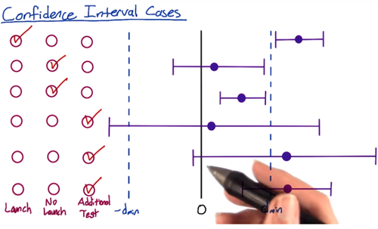

A/B test:

1. What risk is company being exposed to?
2. What benefit might be the outcome of the test?
3. What other choices do we have?
4. What expectation of privacy do they have?

Lesson 3

Define metric

Video 6:

create a funnel: the reason this’s call funnel is that you have fewer and fewer user that get to each stage of the funnel.

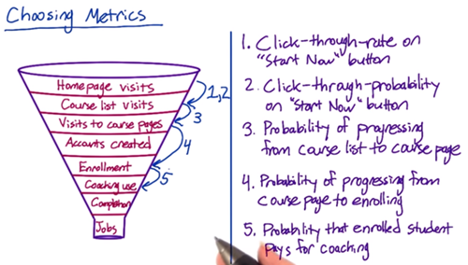

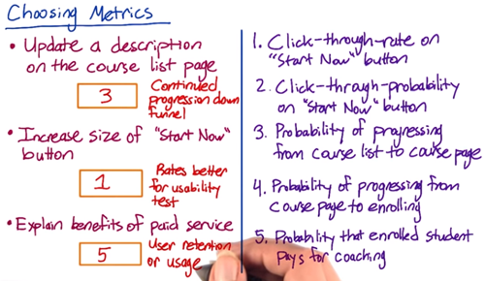

how many months were they active on the site? You want to get some baseline for that. And then given that they took a second course, then you might also want to trigger survey that happened within your site. Get a survey that says “ are you considering…

**video 7: Techniques to Gather Additional Data**

<https://s3-us-west-2.amazonaws.com/gae-supplemental-media/additional-techniquespdf/additional_techniques.pdf>

Eye-tracking cameras: Tobii is the most common manufacturer of cameras that can track eye movement to see what users are looking at

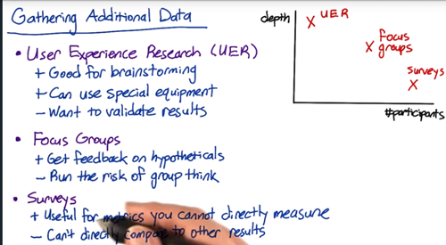

**Video 8: Other Techniques: Example**

Buy external data from Comscore, hitwise, Nielsen

For example, watching the customers try to complete the checkout can help you figure out

* Do they understand where to click?
* Can they find everything on the screen?
* Tracking the latency

**Video 13 Metric Definition: Example**

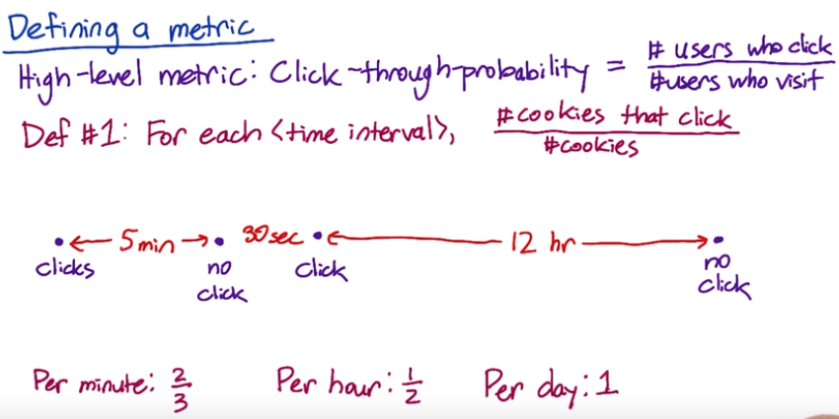

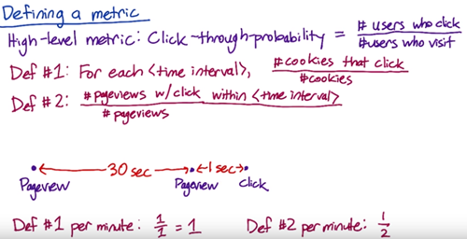

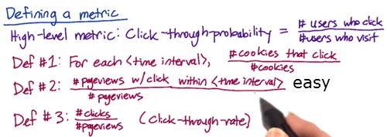

Def #1 (Cookie probability): For each <time interval>, number of cookies that click divided by number of cookies

Def #2 (Pageview probability): Number of pageviews with a click within <time interval> divided by number of pageviews

Def #3 (Rate): Number of clicks divided by number of pageviews

There’s some technical issue(double click, back button caches page, click bug) that will affect the click/views accuracy. Check the video quiz

**Video 14**

There’s some fraud, spam, want to filter that out. You don’t want to dilute your result.

One way to figure out whether you’re biasing or de-biasing your data by applying these filters, is to slice your data, and what this means is that you’re computing your metric on a bunch of disjoint sets. So for example, by country, by language, or by platform. To identify spam and spot something that looks unusual.

You’re building intuition, you have to know what changes you’re going to be expected versus unexpected.

**Video 15 filtering and segmenting**

Looking at different segment of your data can be useful for evaluating metric definitions. Look at how the different definitions vary by segment.

e.g. There’ a weird spike that showed up sometime last week. *Analyze the spike by dividing current week’s data by last week and plot it, to see if the spike still there or not, if spike disappears, which means there’s a weekly variation.* If spike is there, one way to figure out is by looking at this metric across different segments of our population to see if one segment is causing the spike. So let’s trying to look at how this metric varies by country. What’s interesting here is that we don’t see the spike in most countries, but we do see it in Canada, so that one country was causing the entire spike.

You can also see some weekly variation.

If it’s being artificially inflated by double clicks being recorded. It’s hard to know how much higher you would expect the rate to be.

**Video 16 Summary Metrics - establish a few characteristics for your metric**

**First one** is going to be the sensitivity and robustness, to be sensitive enough to detect a change

**Second one** is to characterize what the distribution of metric looks like. e.g. ideal way of doing this is to do a retrospective analysis, to compute a histogram.

**4 categories:**

* sum or count
* Distributional metric: the means, mediams, the 25th, 75th percentiles
* Probabilities and rates
* Ratios

For example, let’s measure the rate at which users click on a result on our search page, analogously, we could measure the average staytime on the results page before traveling to a result. In this case, you’d probably see what we call a [Poisson distribution](http://en.wikipedia.org/wiki/Poisson_distribution), or that the stay times would be [exponentially distributed](http://en.wikipedia.org/wiki/Exponential_distribution).

<https://youtu.be/jmqZG6roVqU>

Another common distribution of user data is a “power-law,” [Zipfian or Pareto distribution](http://en.wikipedia.org/wiki/Pareto_distribution). That basically means that the probability of a more extreme value, z, decreases like 1/z (or 1/z^exponent). This distribution also comes up in other rare events such as the frequency of words in a text (the most common word is really really common compared to the next word on the list). These types of heavy-tailed distributions are common in internet data.

Finally, you may have data that is a composition of different distributions - latency often has this characteristic because users on fast internet connection form one group and users on dial-up or cell phone networks form another. Even on mobile phones you may have differences between carriers, or newer cell phones vs. older text-based displays. This forms what is called a mixture distribution that can be hard to detect or characterize well.

The key here is not to necessarily come up with a distribution to match if the answer isn’t clear - that can be helpful - but to choose summary statistics that make the most sense for what you do have. If you have a distribution that is lopsided with a very long tail, choosing the mean probably doesn’t work for you very well - and in the case of something like the Pareto, the mean may be infinite!